Migrate to Amazon RDS

Shantanu Sahay

RA2011028010078

PROCEDURE:

Login to your AWS account

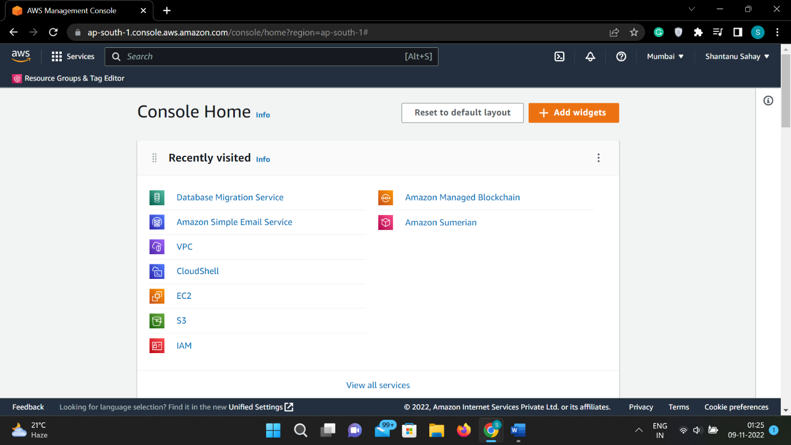

Search for DATABASE MANAGEMENT SERVICE

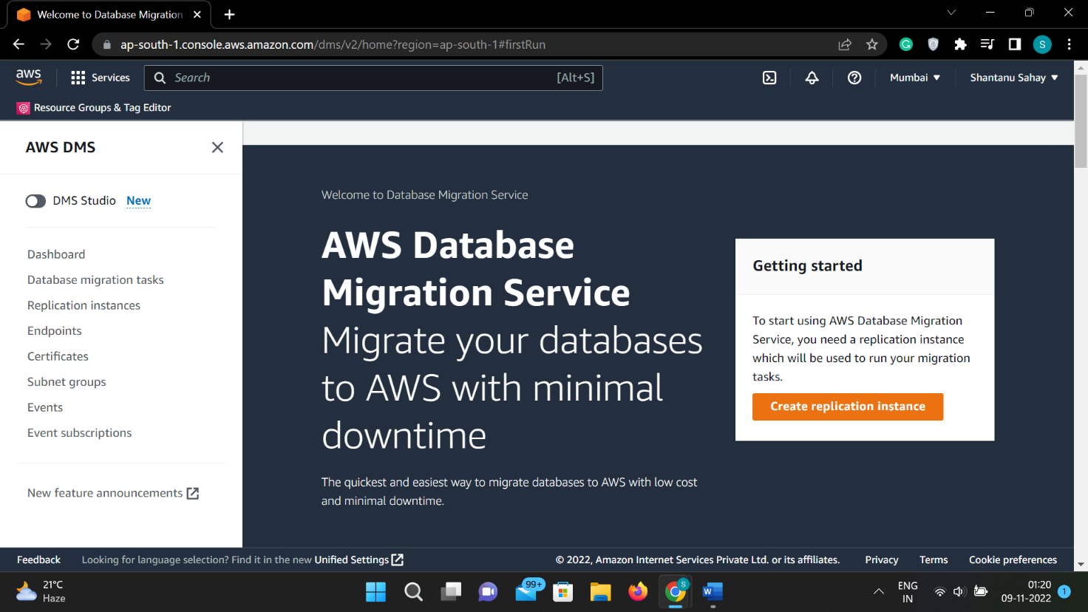

Open REPLICATION INSTANCES

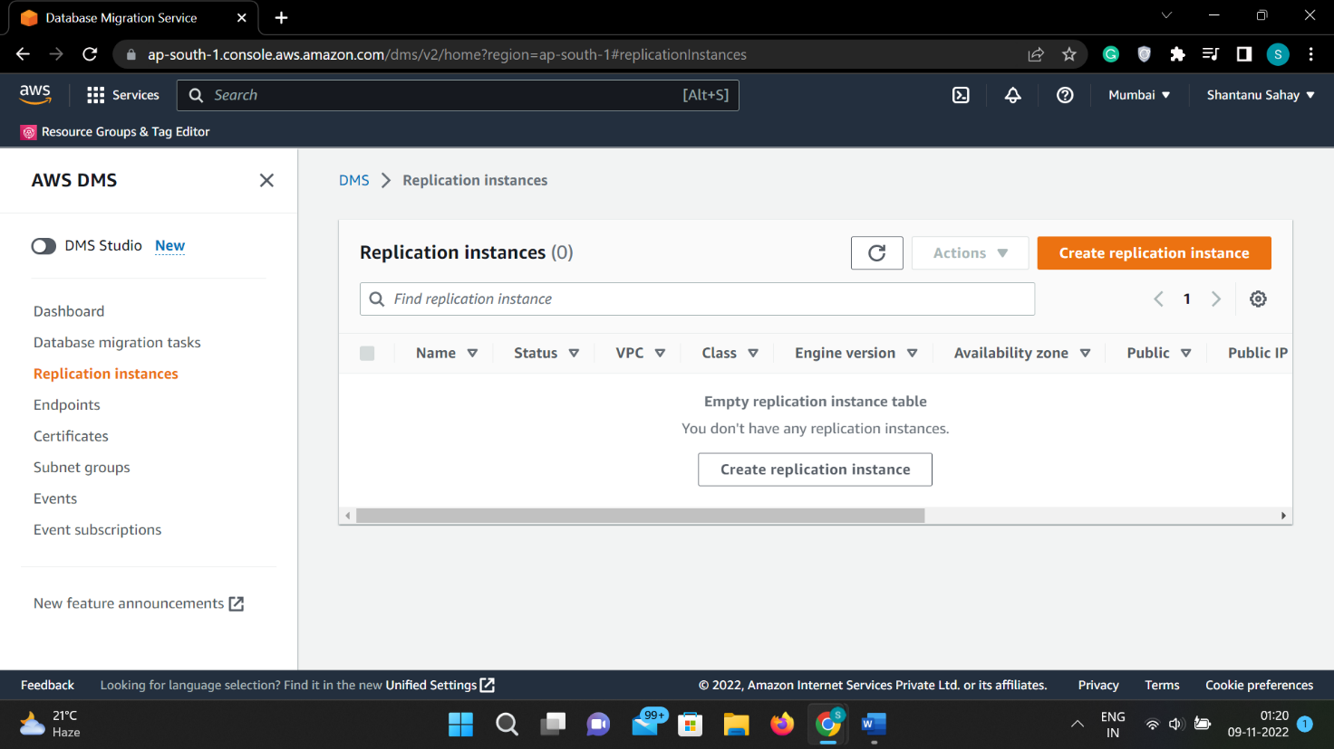

Click on CREATE REPLICATION INSTANCE

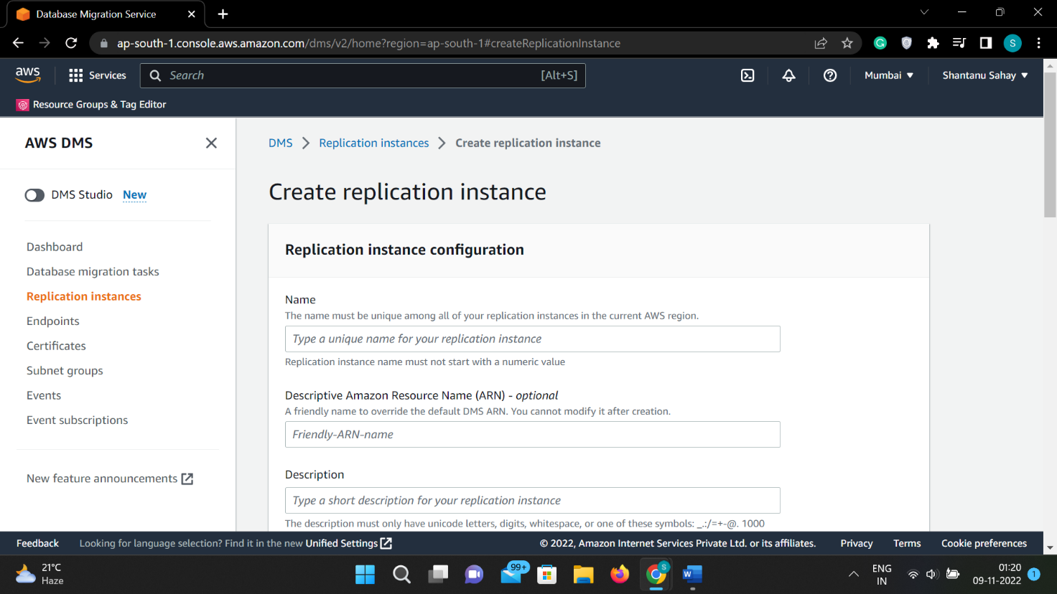

From the console choose ENDPOINTS and create endpoint

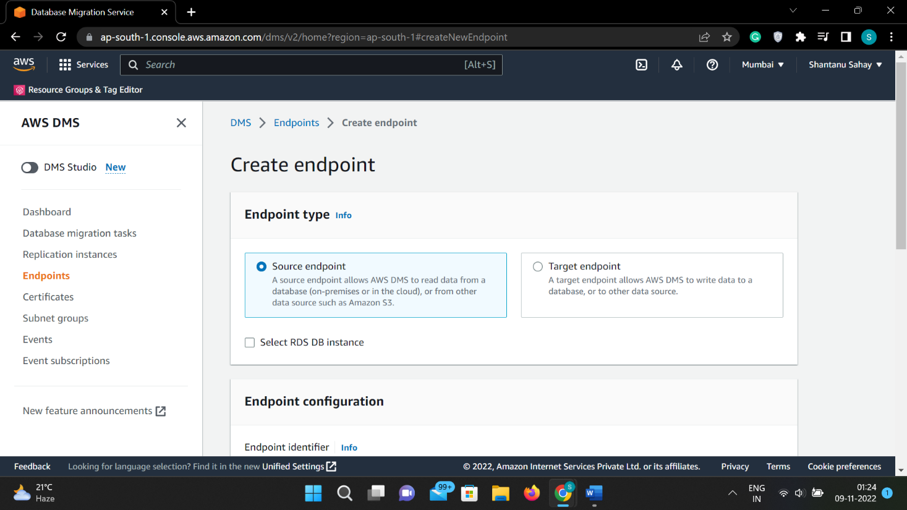8.

Select the ENDPOINT TYPE

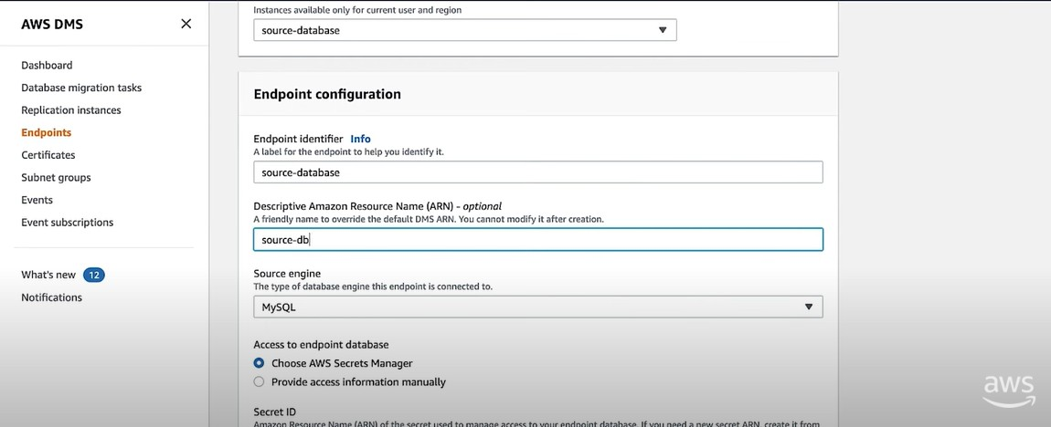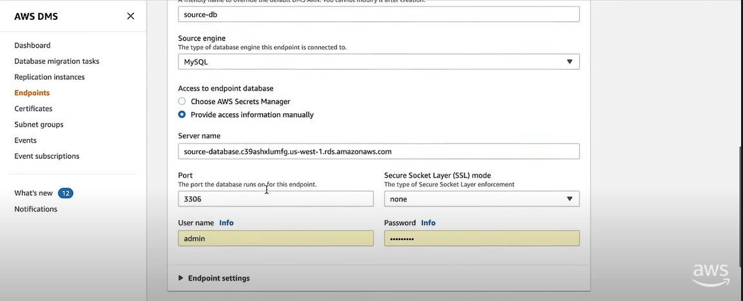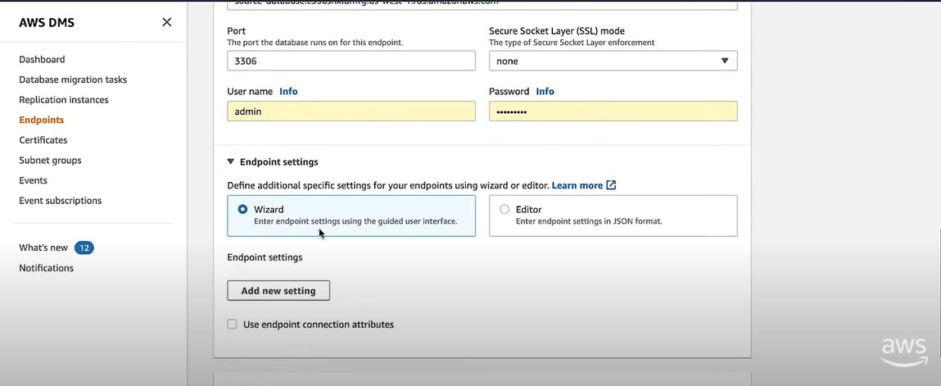9.

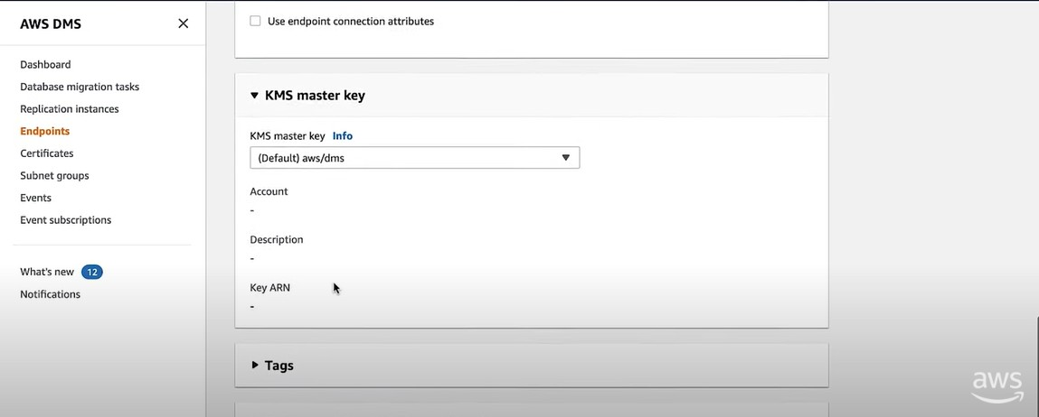

Give the required information

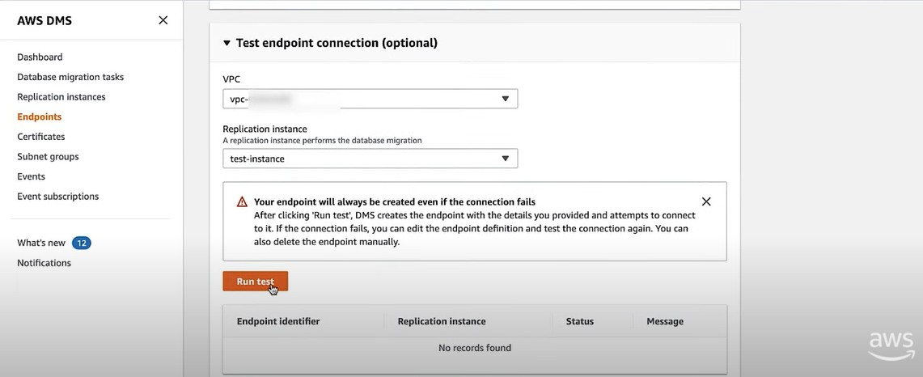10.

Choose RUN TEST button and when the status is successful click on CREATE ENDPOINT

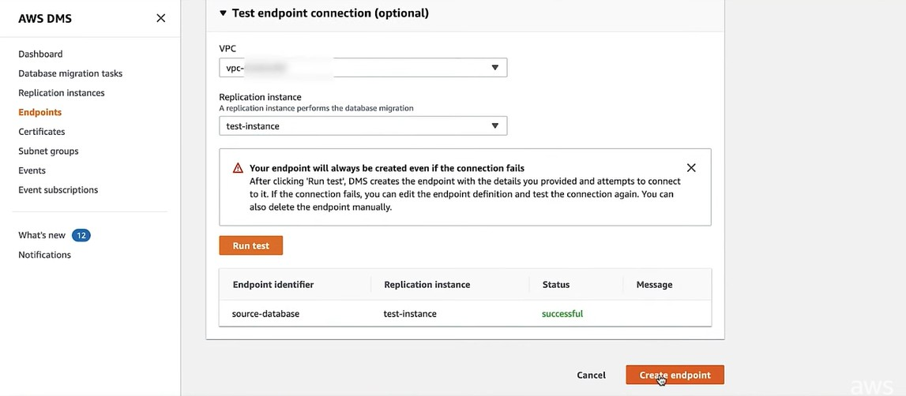

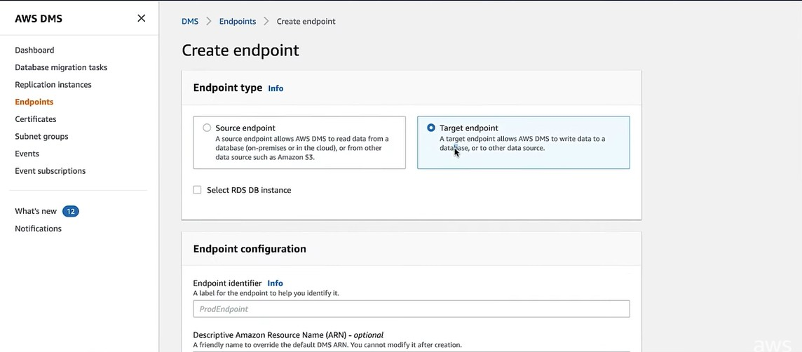11.

Repeat the above steps to create an instance but this ENDPOINT TYPE is Target endpoint 12.

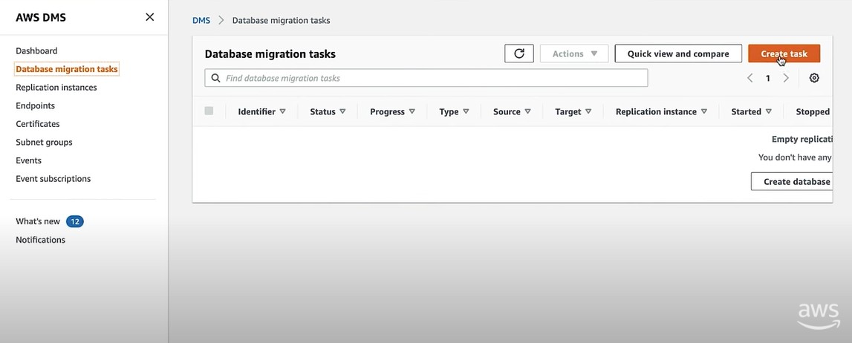

Choose the DATABASE MIGRATION TASKS on the console and choose CREATE TASK

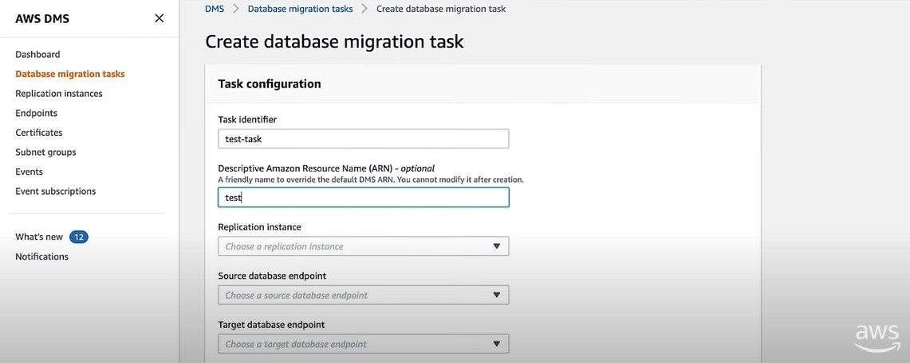13.

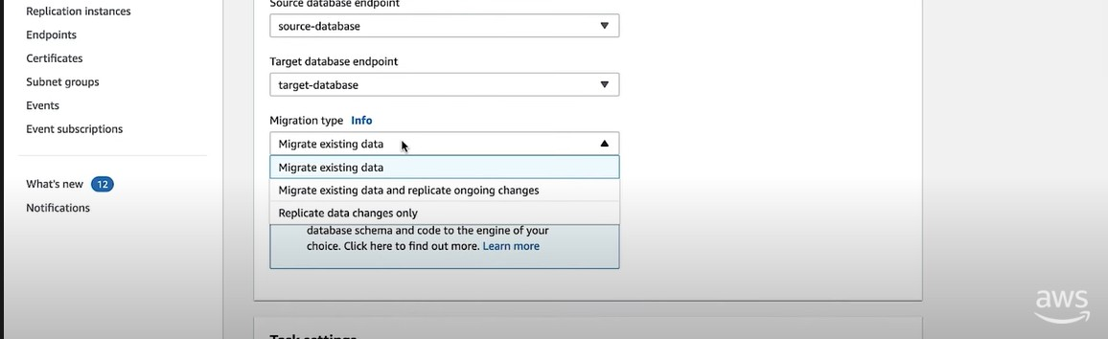Create the task by giving required details 14.

Click on Migrate existing data for one time migration and in task setting update the fields as required. 15.

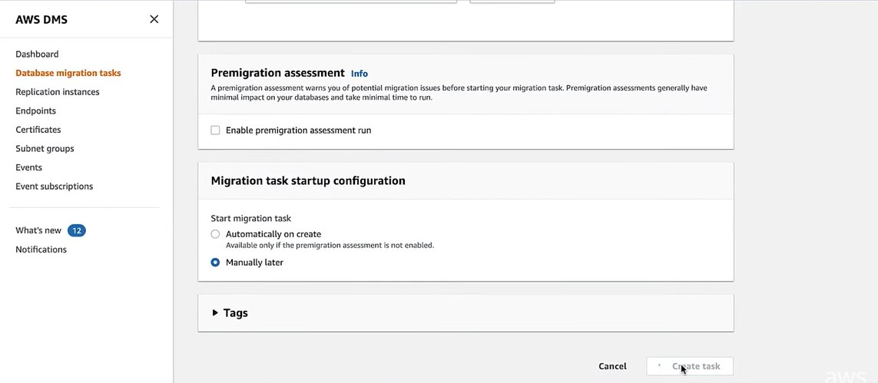

After giving the required details choose create task.

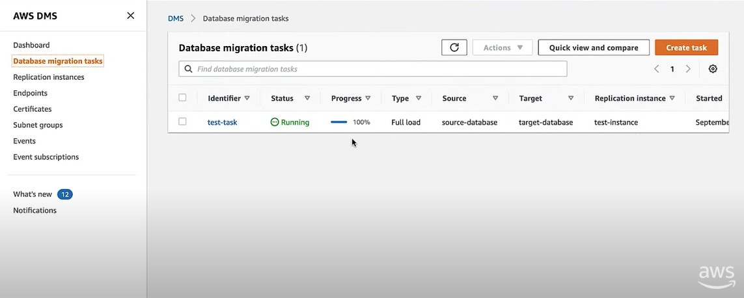16.

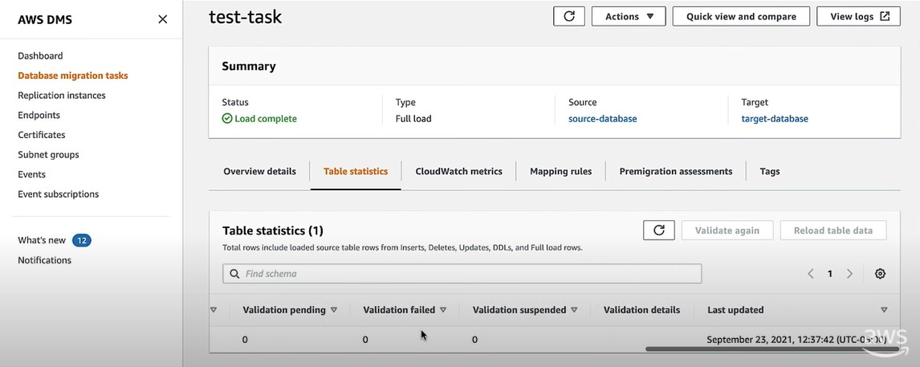Run the task. 17.

Click on the task and click TABLE STATISTICS to view the successfully completed tasks.